NANNY PAWS CARE
A Cross-Platform Pet Sitting and Management Application
ADMINISTRATOR MANUAL
Web Application
A Capstone Project Documentation
Presented to the Faculty of the College of Computer Studies, Silliman University
Prepared by Aki B. Maeda, Sherall Bless A. Abiera, Voughn John Zoe N. Villalon
September 2026 (modules updated 9/17/2026)

1. Signing in and session rules
Purpose. The web panel authenticates against the ADMIN account. Mobile owner and sitter credentials are not used here.
Procedure
Step | Action
1 | Open the administrator website login page.
2 | Enter the administrator email and password.
3 | Click Sign In / Login. The Bookings page is displayed.
4 | Confirm that the sidebar lists Bookings, Pet Sitters, Messages, Applicants, Feedbacks, Business Earnings, and Maintenance.

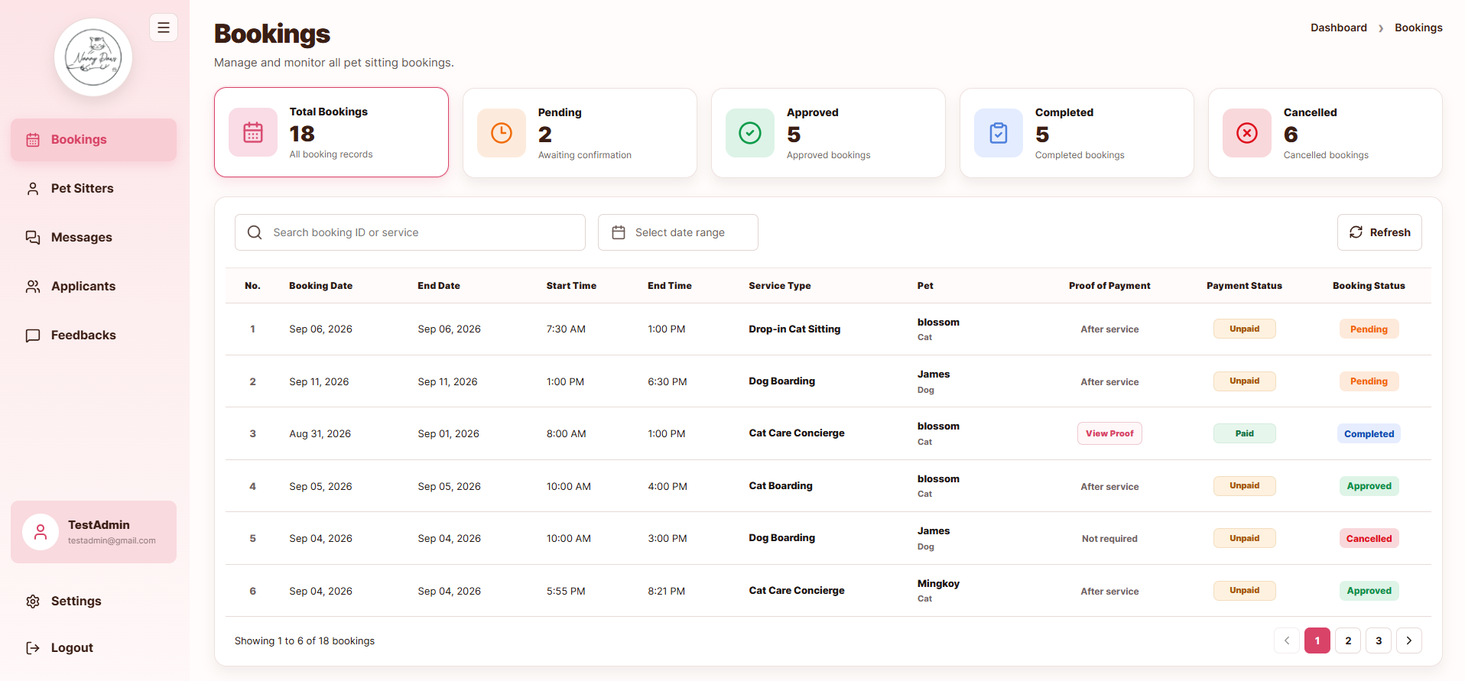
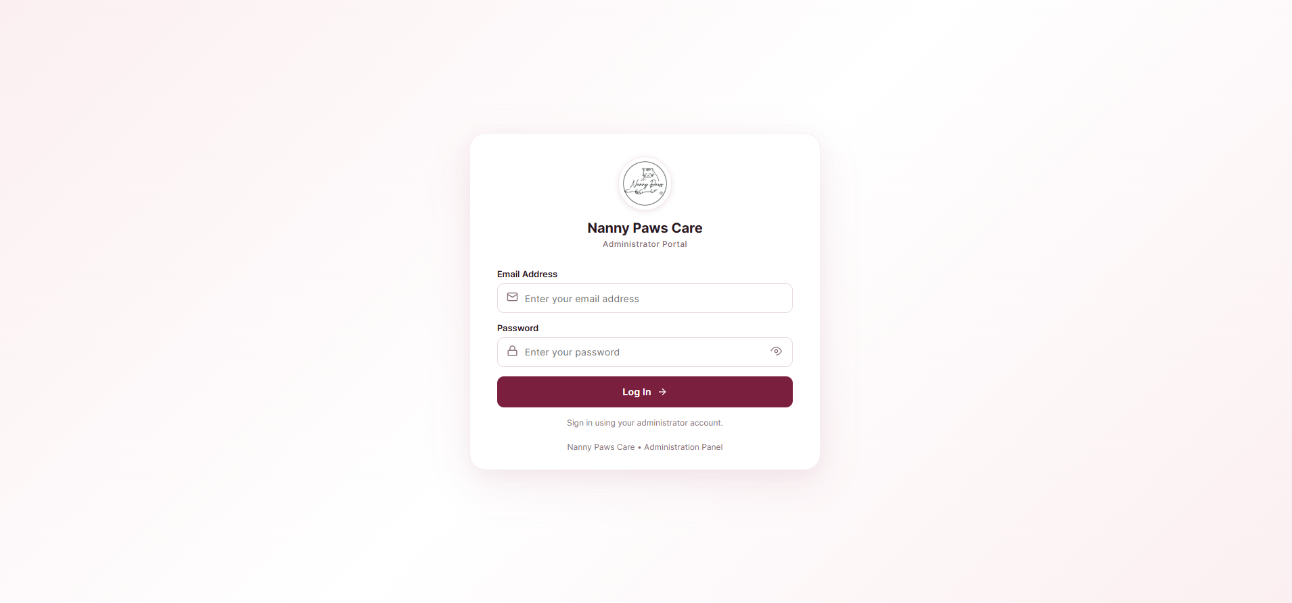
Figure 1. Administrator login page
Note. Only one active session is kept per administrator account. After approximately 30 minutes of inactivity the session ends and the login page is shown.
2. Bookings overview
Purpose. Every row in the bookings table was created by a pet owner on the mobile application.
Procedure
Step | Action
1 | Click Bookings in the sidebar.
2 | Verify Start Date, End Date, Start Time, End Time, Service Type, Pet, Proof of Payment, Payment Status, and Booking Status.
3 | Read Pending as an owner submission awaiting review. Approved on this screen is stored as Confirmed for the mobile applications.
4 | Read Payment Status using the mobile lifecycle: Not Due, Unpaid, Pending Review, Awaiting Cash Confirmation, and Paid.
5 | Click a row to open details, including instructions and the signed waiver PDF.
6 | Use status filters as needed. Filtering does not change stored values.

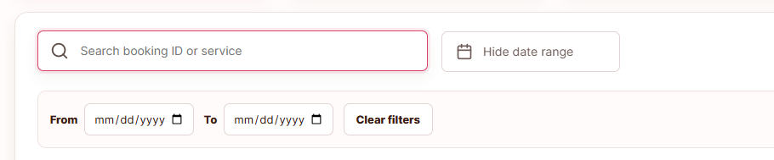
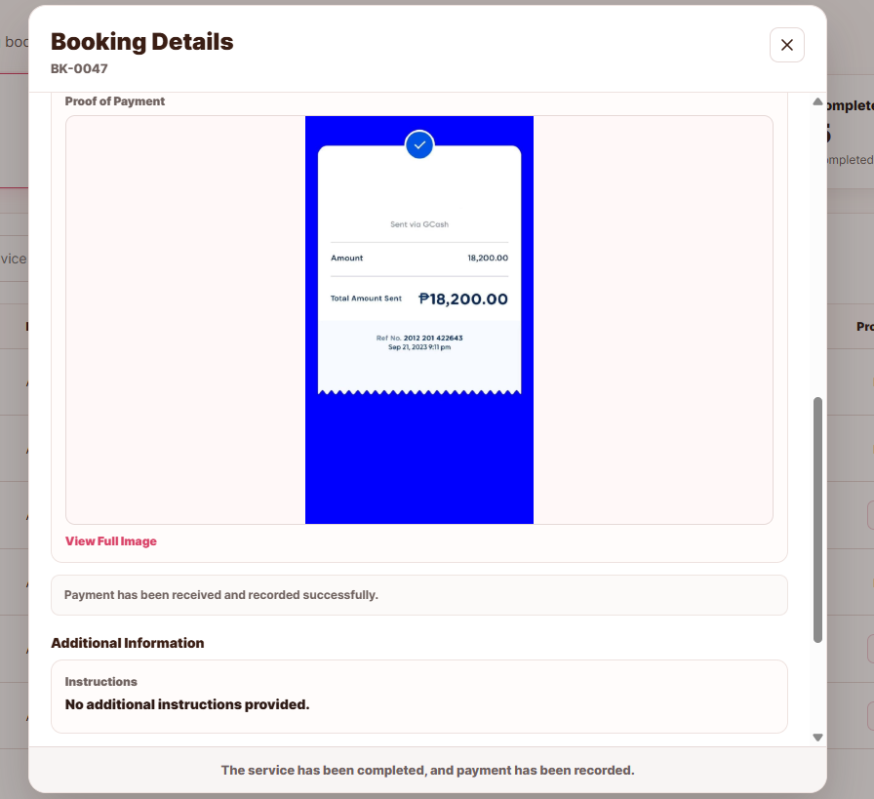
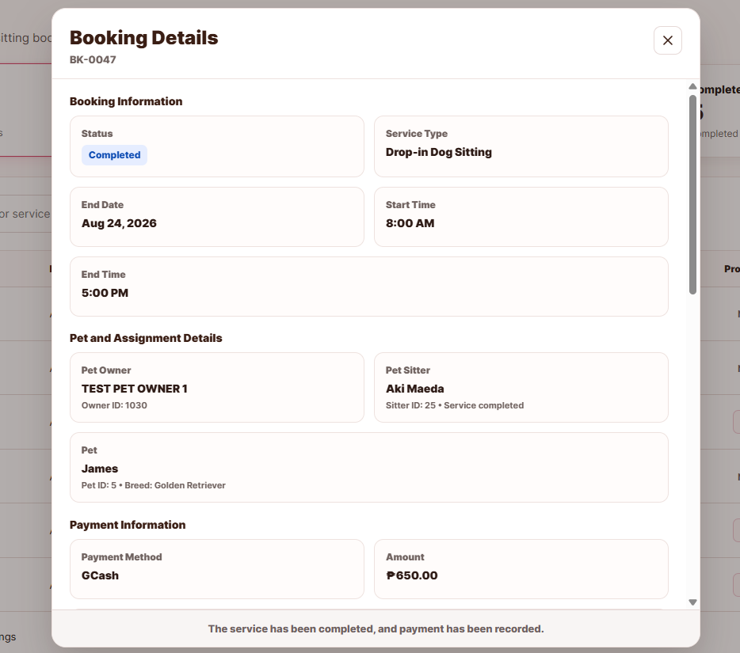
Figure 2. Filtering and Booking details
3. Approving or cancelling a booking
Purpose. The administrator changes Pending bookings only. Completion is performed by the pet sitter on mobile after the visit ends.
Procedure
Step | Action
1 | Open a Pending booking.
2 | Optionally enter review notes.
3 | Click Approve/Confirm Booking and confirm. The owner is notified. The sitter sees the booking as confirmed.
4 | Or click Cancel Booking and confirm. Cancelled bookings do not require payment.

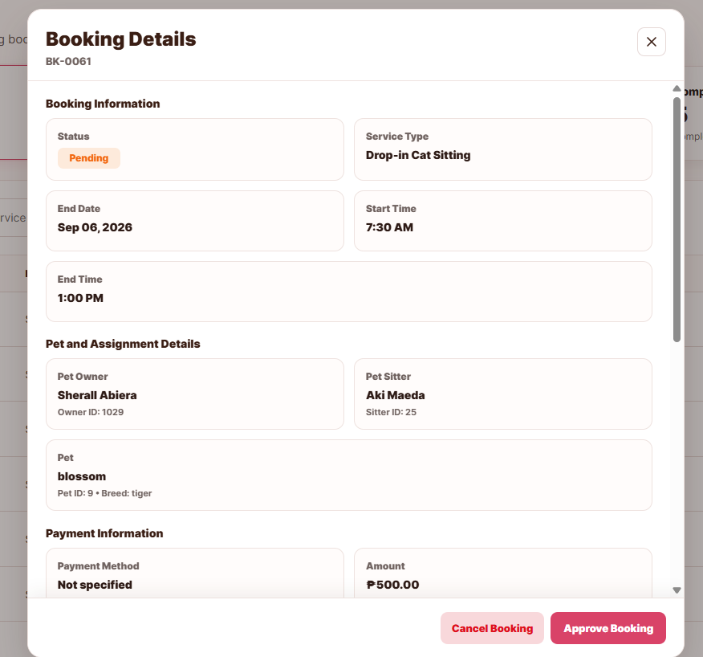
Figure 3. Booking details with Approve Booking and Cancel Booking
Note. There is no Mark Completed control on an Approved/Confirmed booking. The pet sitter updates the booking once the service is completed.
4. Confirming payment after completion
Purpose. Payment begins only when the sitter has set the booking to Completed.
Procedure
Step | Action
1 | Open a Completed booking.
2 | If the owner paid by GCash, Payment Status is Pending Review and a proof image is attached. Open the proof, click Mark as Paid, and confirm.
3 | If the owner chose Cash, Payment Status is Awaiting Cash Confirmation (Cash Pending). Confirm cash was received, then click Mark as Paid. No image is required.
4 | If the owner has not paid, Payment Status remains Unpaid and Mark as Paid is not used for GCash until proof exists.

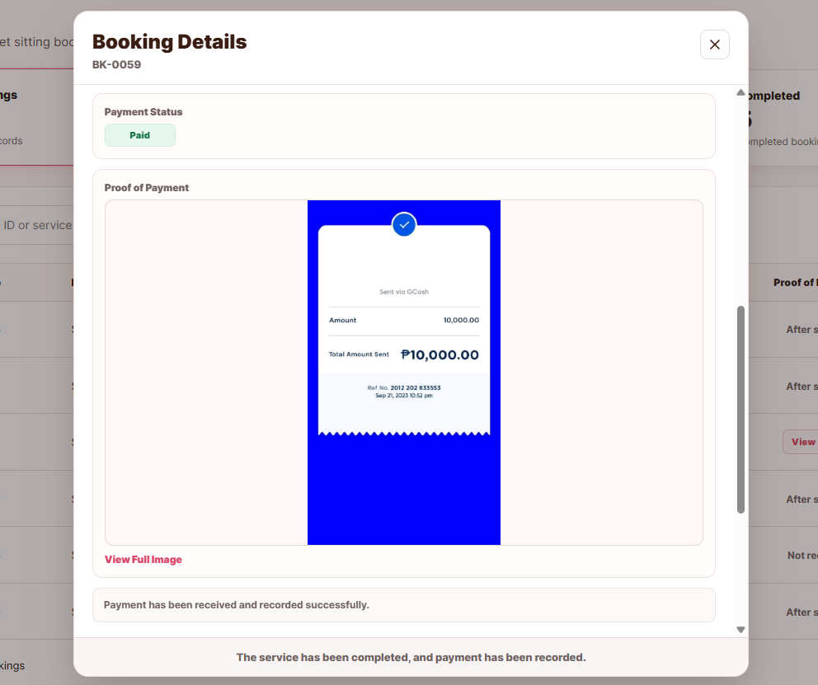
Figure 4. Completed booking with Mark as Paid
Note. Mark as Paid is not available on Pending or Approved bookings. Paid bookings feed Business Earnings snapshots.
5. Reviewing sitter applicants
Purpose. Applicants are submitted from Apply Here on the mobile Login page. Accepting an applicant creates the sitter login.
Procedure
Step | Action
1 | Click Applicants in the sidebar.
2 | Open a Pending application and review name, contact, email, address, preferred pet type, schedule, place photographs, and resume.
3 | Click Accept and confirm Accept & Create Sitter when the record is complete. The application becomes Accepted/Approved and a PET SITTER account is created.
4 | Provide the issued login details so the sitter can sign in on mobile.
5 | Or enter remarks, click Reject, and confirm Reject Application. No sitter account is created.

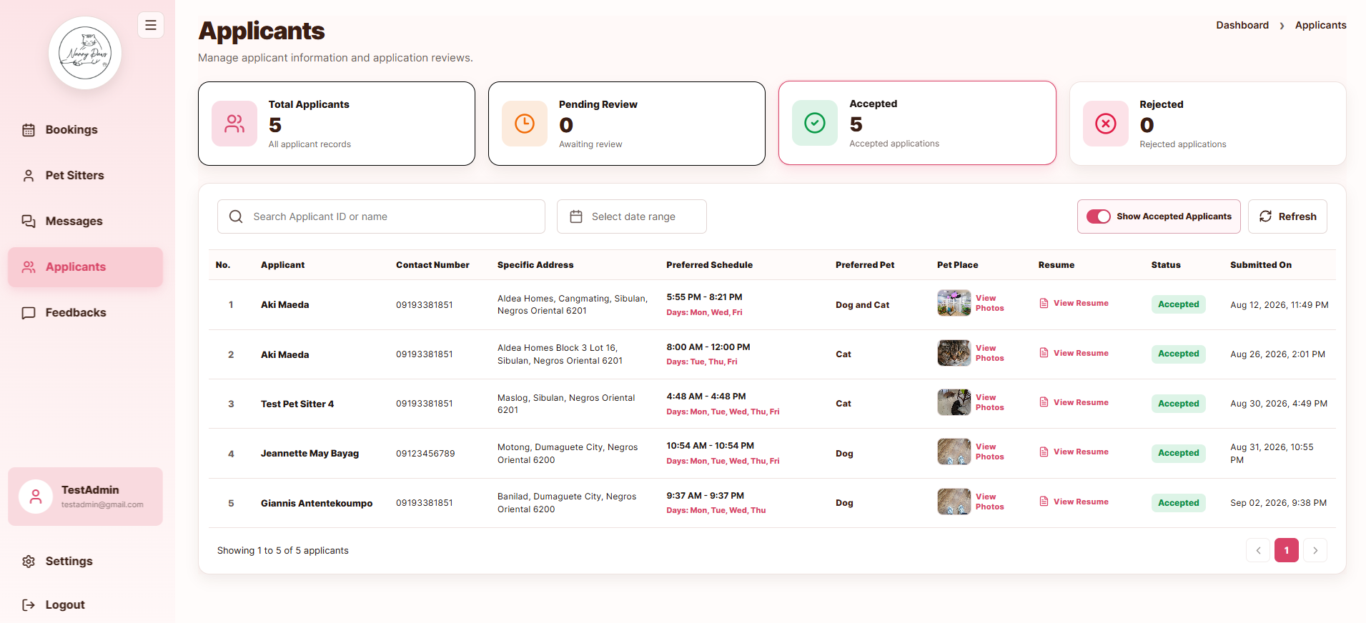
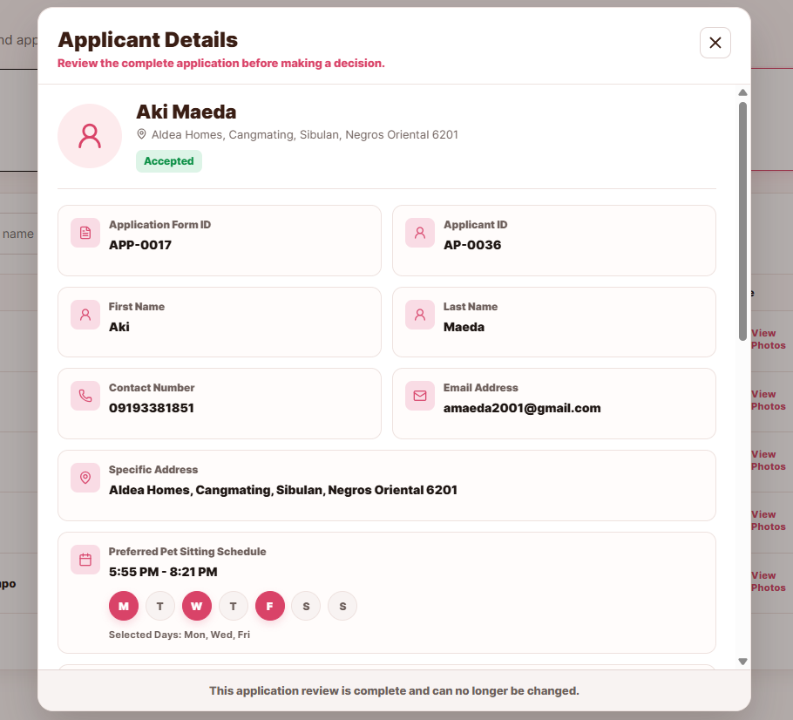
Figure 5. Applicants list and Applicant details
6. Managing pet sitters
Purpose. The Pet Sitters page lists accounts created from accepted applications. Edit and delete are separate actions.
Procedure
Step | Action
1 | Click Pet Sitters in the sidebar.
2 | Verify name, username, contact, email, preferred pet type, and photograph.
3 | Filter by Dog, Cat, or Both when required.
4 | Open a sitter, edit allowed fields, and save. Email is locked once the sitter authentication account exists.
5 | To remove a sitter, click Delete Sitter and confirm.

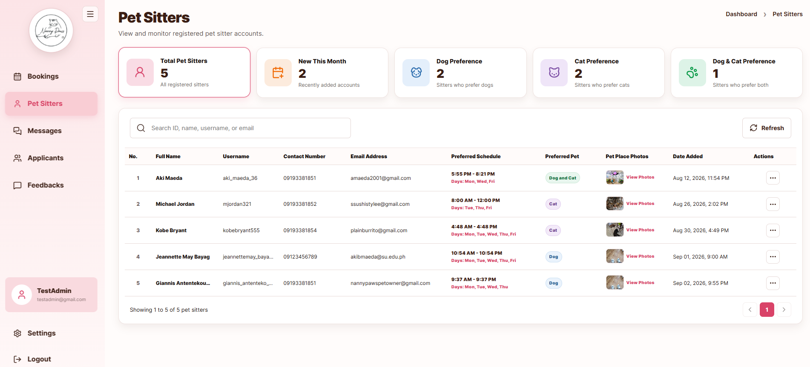
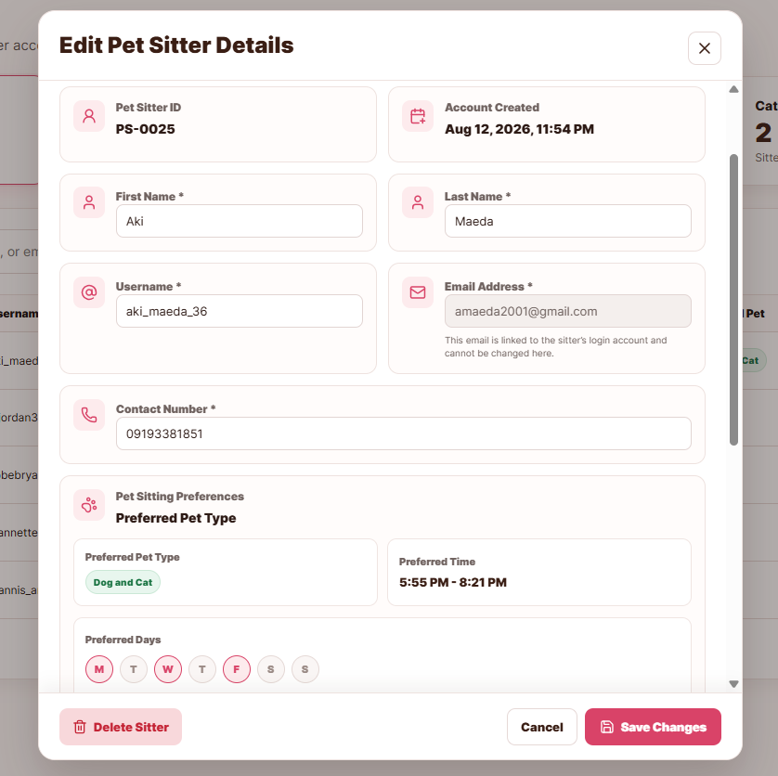
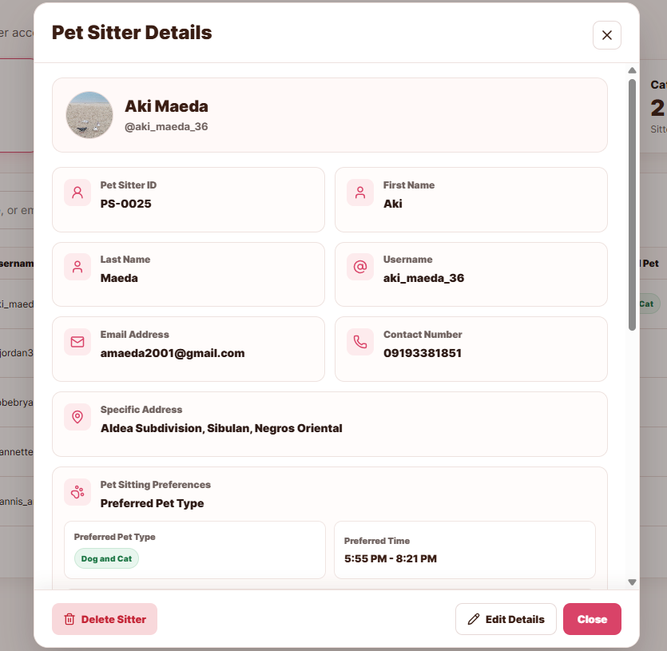
Figure 6. Pet Sitters list and Edit or Delete a Pet Sitter
7. Monitoring messages
Purpose. Conversations are copied from the mobile owner–sitter chat. The administrator cannot send a reply from the web panel.
Procedure
Step | Action
1 | Click Messages in the sidebar.
2 | Open a conversation and read the thread, including photographs if any were sent.
3 | Confirm that no compose or send control is present.

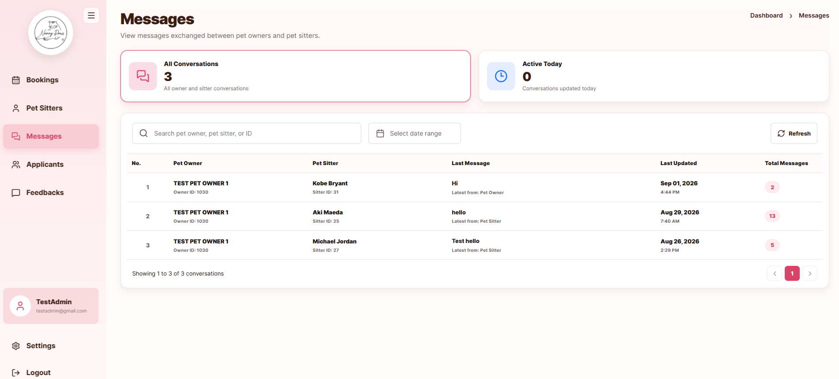
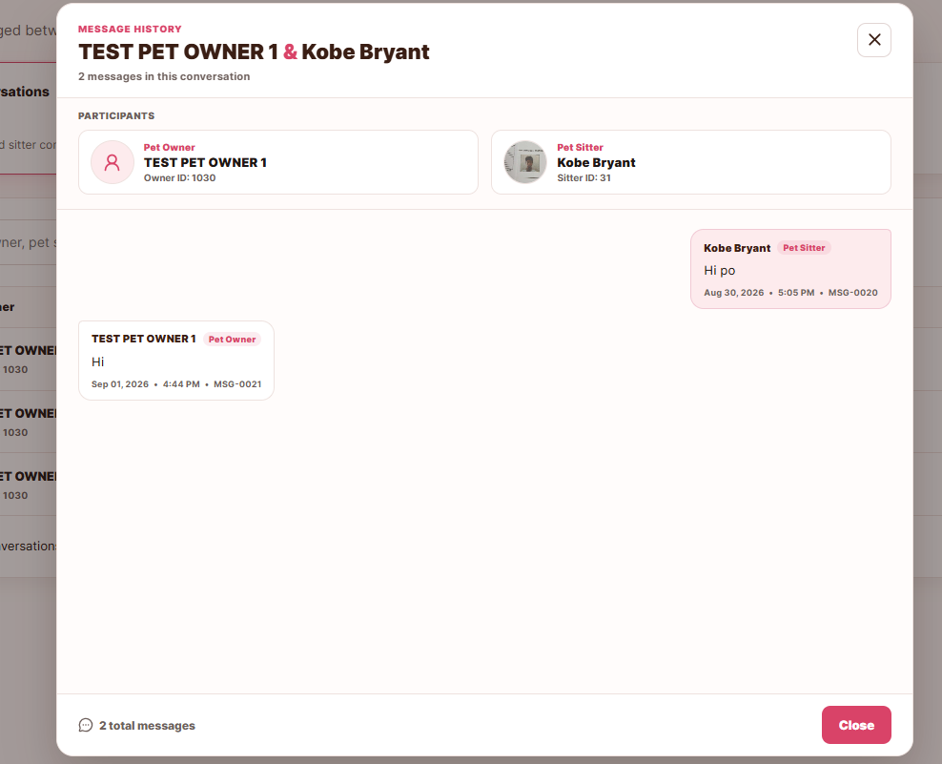
Figure 7. Administrator Messages (read-only)
8. Reviewing and deleting feedbacks
Purpose. Owners submit ratings after a completed booking.
Procedure
Step | Action
1 | Click Feedbacks in the sidebar.
2 | Verify rating, comments, owner name, sitter name, and date.
3 | Filter by rating, or open the positive (4–5) and negative (below 4) summary cards.
4 | To remove a record, click Delete, then confirm.

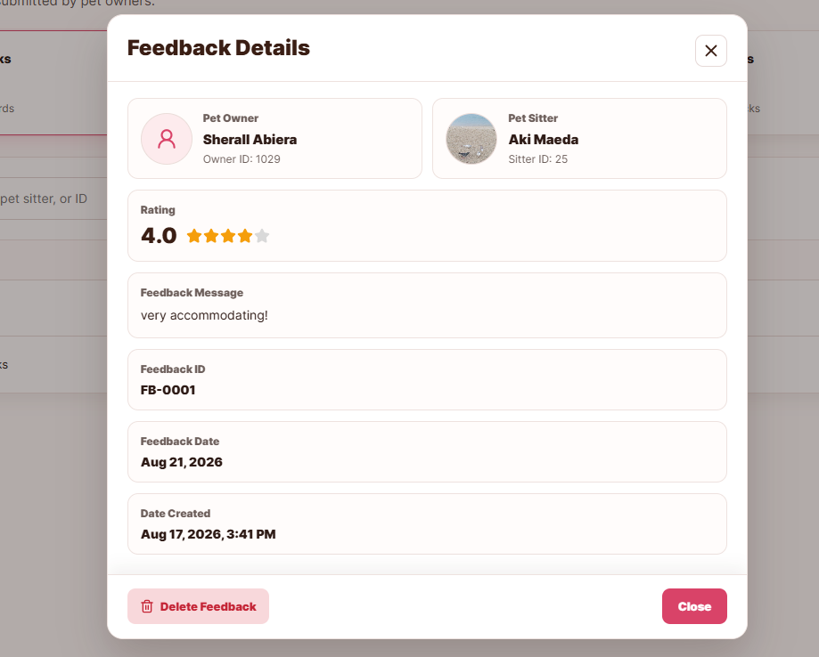
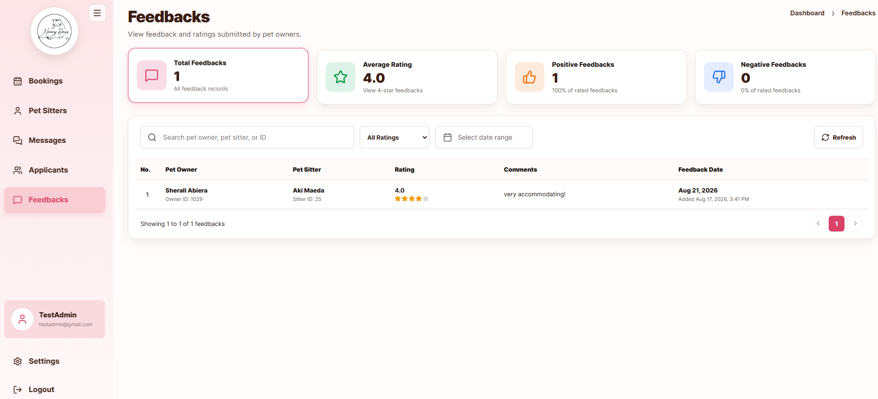
Figure 8. Feedbacks page
9. Business Earnings
Purpose. Business Earnings is a password-gated financial dashboard separate from the regular Admin login. It shows revenue and share allocations for Completed+Paid bookings.
Procedure
Step | Action
1 | Click Business Earnings in the sidebar.
2 | Enter the Business Owner access password and click Open Financial Dashboard.
3 | Review Total Revenue, Business Owner Earnings, Pet Sitter Earnings, and Total Transactions.
4 | Search or filter the transaction table by booking, service, sitter, or date range.
5 | Optionally change the Business Owner access password, then lock the dashboard when finished.

[Figure 9. Business Earnings password gate and financial dashboard]
Note. Historical transactions keep the revenue split recorded when they were finalized. Later Maintenance changes do not rewrite past snapshots.
10. Maintenance
Purpose. Maintenance manages the service catalog used by mobile bookings and the per-sitter revenue share used when earnings are finalized.
Procedure
Step | Action
1 | Click Maintenance in the sidebar.
2 | In Service Catalog, filter Dog/Cat/All or search by service name.
3 | Open a service (Drop-in, Boarding, or Care Concierge). Update name, description, and Base/Medium/Large prices, then confirm Save Changes.
4 | In Pet Sitter Revenue Share, open a sitter and set the Pet Sitter percentage (0–100). The Business Owner share is the remainder.
5 | Confirm and Save Revenue Share. Changes apply to future Completed+Paid bookings only.

[Figure 10. Maintenance service catalog and revenue sharing]
Note. Price updates can cascade to non-finalized bookings. Finalized Business Earnings rows remain frozen.
11. Profile and display settings
Purpose. The administrator email is display-only. Username and password may be changed. Display settings apply only to this browser.
Procedure
Step | Action
1 | Open Profile. Confirm that the email cannot be edited.
2 | To change the username, enter a new username and the current password, then save.
3 | To change the password, enter the current password and a new password of at least eight characters with uppercase, lowercase, a digit, and a special character. Confirm and save.
4 | Open Settings. Select Large font if required, enable Dark mode if required, and save. These choices do not change the mobile applications.

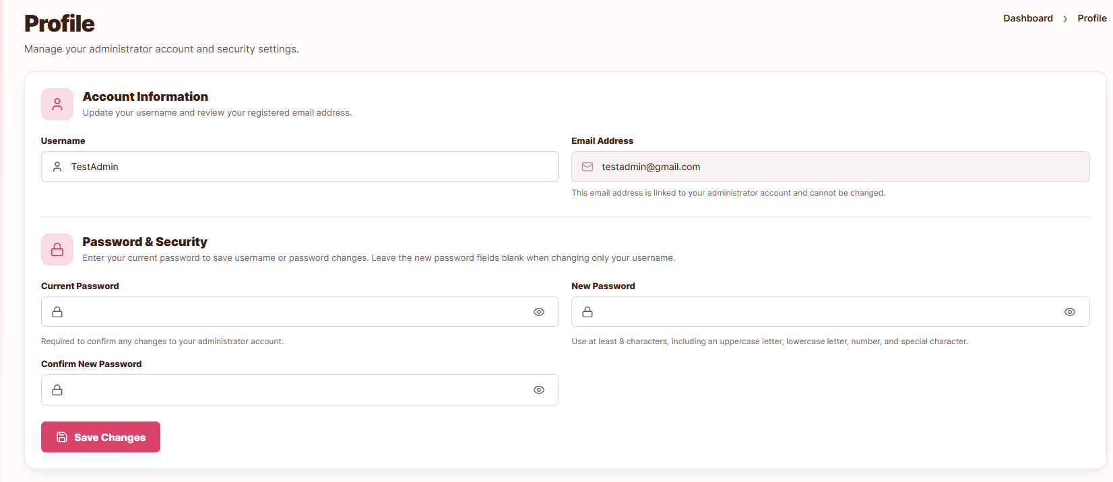
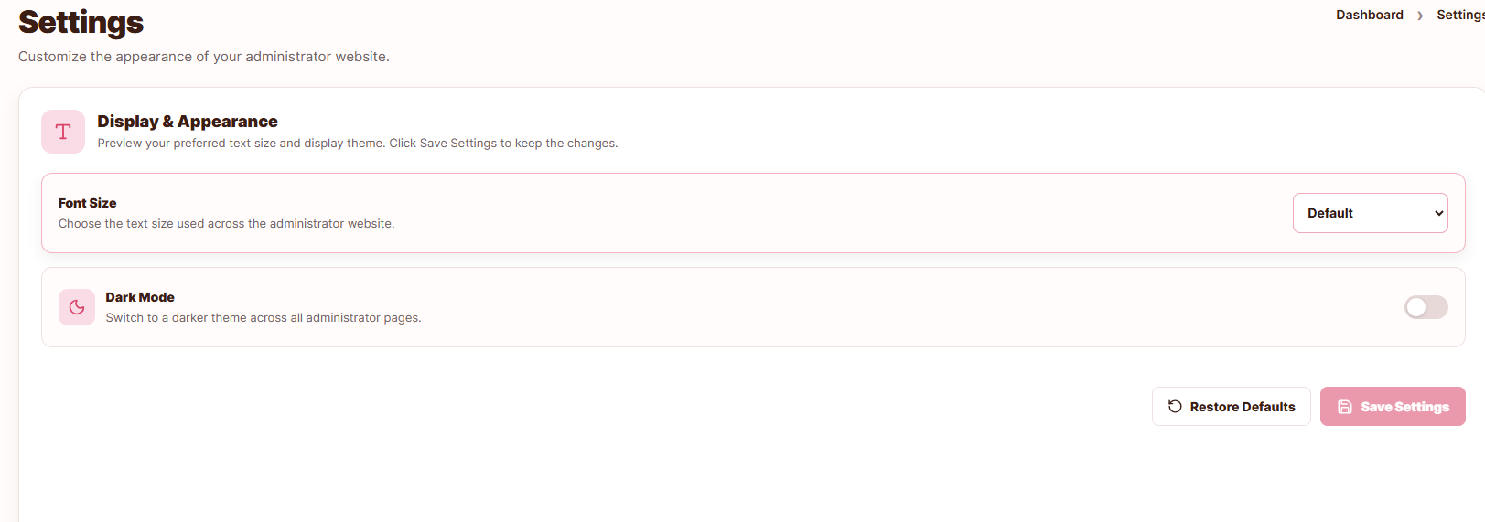
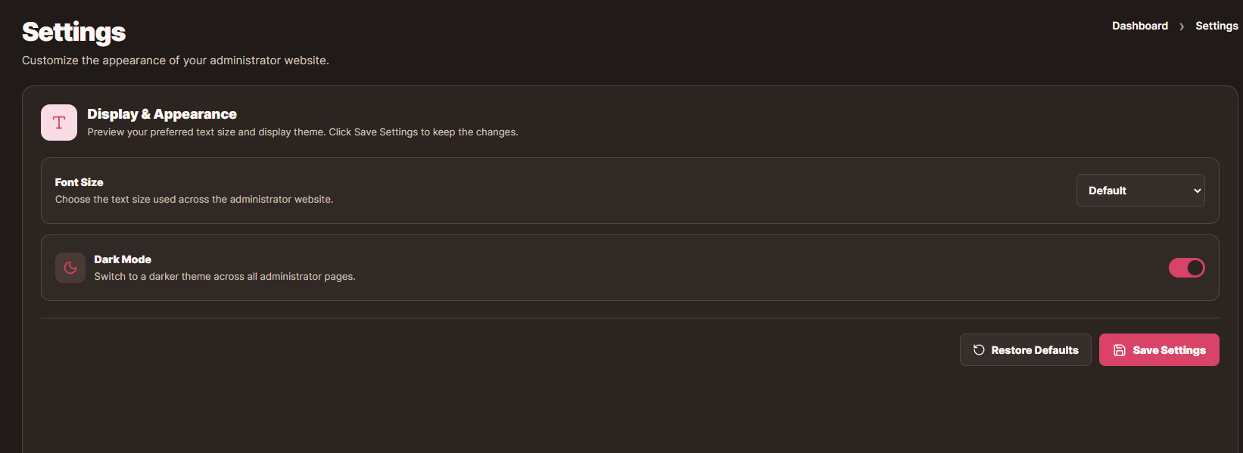
Figure 11. Administrator Profile and Settings
12. Signing out
Purpose. Signing out ends the administrator session lock so the account may be used on another device.
Procedure
Step | Action
1 | Click Log out in the sidebar.
2 | Confirm that the login page is displayed.
3 | Attempt to open a protected route such as /bookings and confirm that it returns to login.

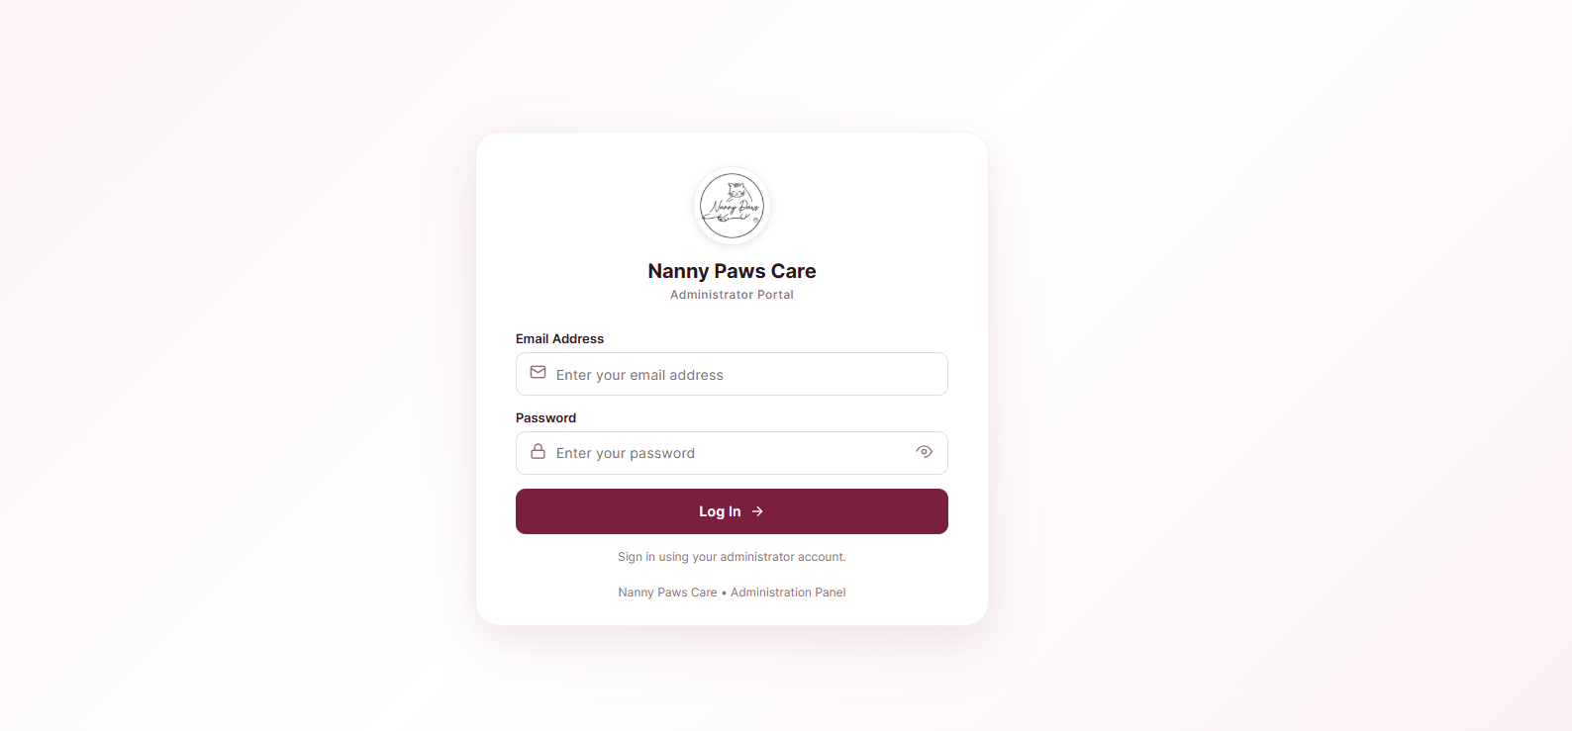
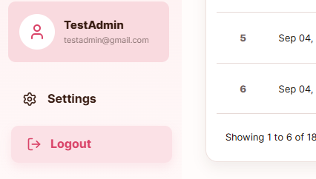
Figure 12. Administrator login page after sign-out

